

**Group Coursework Submission Form**

Specialist Masters Programme

|  |  |  |
| --- | --- | --- |
| **Please list all names of group members:**  (Surname, first name)  1. Farrakhov, Bulat  2. Gan, Haozhi  3. Hamade, Ramez | 4. Kalochoritou, Phoebe  5. Karwa, Radhika  6. Phan, William  **5**  **GROUP NUMBER:** | |
| **MSc in:**  Business Analytics | | |
| **Module Code:**  SMM 635 | | |
| **Module Title:**  Data Visualisation | | |
| **Lecturer:**  Simone Santoni | | **Submission Date:**  11 Nov. 20 |
| **Declaration:**  By submitting this work, we declare that this work is entirely our own except those parts duly identified and referenced in my submission. It complies with any specified word limits and the requirements and regulations detailed in the coursework instructions and any other relevant programme and module documentation. In submitting this work we acknowledge that we have read and understood the regulations and code regarding academic misconduct, including that relating to plagiarism, as specified in the Programme Handbook. We also acknowledge that this work will be subject to a variety of checks for academic misconduct.  We acknowledge that work submitted late without a granted extension will be subject to penalties, as outlined in the Programme Handbook. Penalties will be applied for a maximum of five days lateness, after which a mark of zero will be awarded. | | |
| **Marker’s Comments (if not being marked on-line):** | | |

**%**

**Deduction for Late Submission: Final Mark:**

# Aftermath of the 2016 Brexit Referendum for publicly-listed companies

Introduction

Brexit refers to the withdrawal of the United Kingdom [UK] from the European Union [EU]. In a referendum held on the 23rd of June 2016, UK citizens voted to leave the EU with 51.9% those in favour of Brexit. Since then, a round of negotiations had begun between the EU and the UK. After many arguments, on the 23rd of January 2020, the EU Withdrawal Agreement Act was finally implemented. There were several different reasons why people voted for Brexit and the main one was to gain more sovereignty, take control of immigration and create possible new trade deals with countries outside of the EU like the USA. People, who voted agains Brexit, supported the idea of a wider union with favourable trade deals and good relationships with the EU members. Britain is still in a transition period, which means that it is still under the EU’s customs union and single market, however it is not a part of the political institutions. This paper aims to analyse the aftermath of Brexit on the Stock markets for Germany, France and the United Kingdom.

Descriptive statistical charts

Figure 1: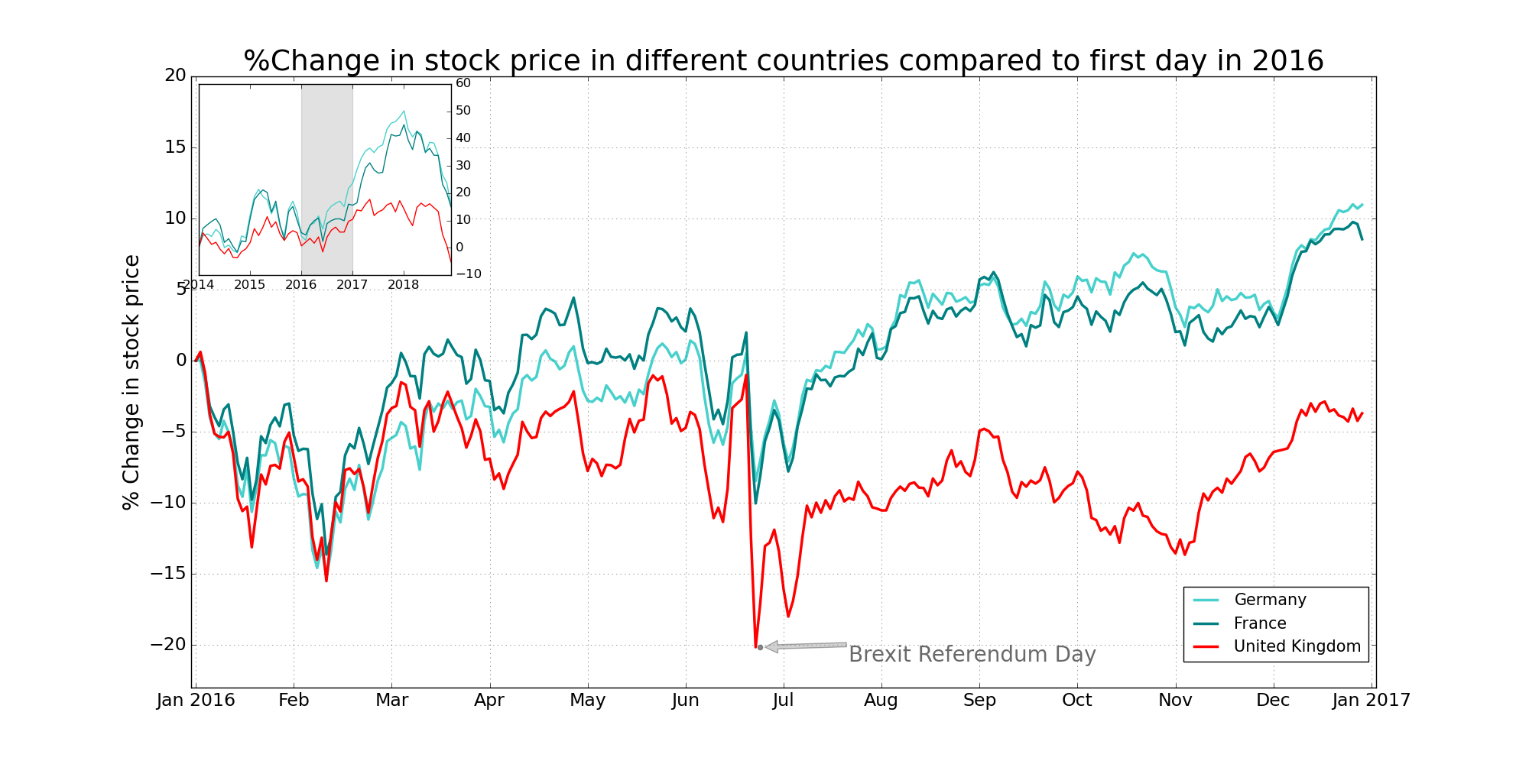

Before 2016 the UK publicly listed companies’ stock price movements were similar to the EU.

Figure 1, shows that on the referendum day there was almost a 20% drop for UK companies. The significant drop signals that investors were not optimistic with the outcome of Brexit. To add, by the end of 2016, all market experienced a “bull market” (an extended period in the market when stock prices are on the rise), but as we can see the growth rate for the UK stock market is much lower compared to the other countries. At the end of 2016, UK was experiencing a growth but still at a negative rate.

Figure 2: 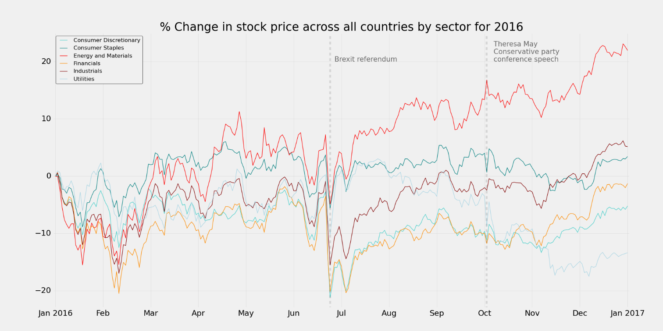

In Figure 2, we have break down the data into sectors to show how each sector reacted to the Brexit Referendum. We can see that half of the sectors averages have fallen below their initial point. The industrial sector has recovered very quickly after the Brexit referendum and we can see an upward trend at the end of 2016. The consumer staples and utility sector did significantly better after the referendum, which links to investors expecting an economic slowdown.

Another important date for the stock market was October 5th, where Theresa May gave a speech at the Conservative Party conference addressing Brexit. We can see a small drop after the speech in all sectors, but a quick recovery for all of them.

The energy and materials sector was not affected much by Brexit, rather than the global situation. Even though it has gotten above 20% growth throughout the year 2016, it is needed to be mentioned that there was a fall in oil prices at the start of the year that help to boost investment.

Furthermore, besides Brexit, there was a global stock market selloff in 2015-2016 due to China’s GDP slower growth, which affected the results.

Figure 3:

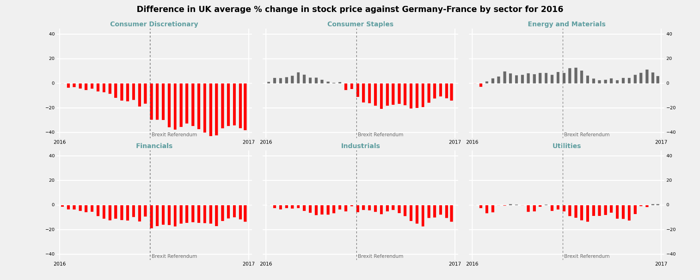

To have a better understanding of the Brexit effects on the UK, Figure 3, shows the difference in UK sectors compared to average changes in stock prices for France and Germany in the same sectors. For the consumer discretionary sector, the difference was growing before the referendum day, but it has increased the gap and slowed growth for the UK sectors when compared to France and Germany. A similar picture is seen in industrials, financials, and utility sectors, even though the utility sector has improved by the end of the year and increased more than the average of France and Germany. UK consumer staples sector has gone from increasing its positive gap to being below about 15% at the end of 2016. The energy and materials sector difference across the three countries was not affected much by the sector and was steadily up around 10% throughout the year.

Figure 4:

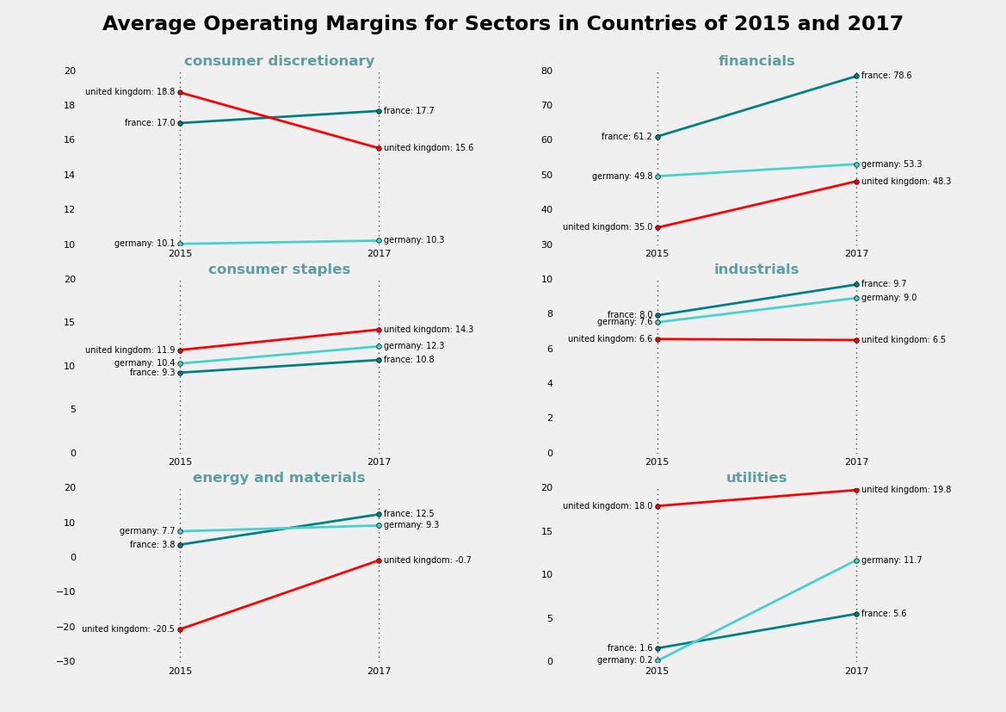

Day-to-day stock price fluctuations are not always the best way to show actual results, as they are affected by investors speculations. To have more accurate results, It might be better to examine the average operating margins as they can be more precise. The patterns we have in Figure 4 partly explain the results from Figure 3 that UK companies performed worst in the consumer discretionary sector and relatively well in energy and materials sector between 2015 to 2017 compared with France and Germany companies. Different researches show that due to possible economic downturn, people spent more money on essential good, rather than discretionary over these years.

Regression analysis

With annual panel data, we run the regression on all the sectors and also on specific sectors:

$${annual}_{i,t}=β_{0}+β_{1}{assets}_{i,t}+β_{2}{operating}_{i,t}+β_{3}{debttoassets}_{i,t}+β_{4}{postbrexit}_{i,t}+β_{5}{treated}_{i,t}+β_{6}{postbrext}_{i,t}×{treated}_{i,t}+ τ_{i}+μ_{i,t}$$

where ${annual}_{i,t}$ denotes the annual returns for each companies; ${assets}_{i,t}$ denotes the companies’ asset values; ${operating}_{i,t}$ stands for operating margin; ${debttoassets}_{i,t}$ stands for debt-to-assets ratio; ${postbrexit}_{i,t}$ is the dummy variable which represents the period after or before the Brexit referendum (equals one when it’s 2017 or 2018, equals zero when it’s 2014-2016); ${treated}_{i,t}$ is the dummy variable which illustrates the difference between UK companies and the France and Germany companies (equals one when it’s UK company, zero when France or Germany); ${postbrext}_{i,t}×{treated}_{i,t}$ is the interactive term; $τ_{i}$ represents the fix effect; $μ_{i,t}$ is the error term.

|  |  |  |
| --- | --- | --- |
|  | consumer discretionary | all-sector |
| post_brexit | 0.1850** | 0.1871*** |
| treated | -0.1149 | -0.2732 |
| post_brexit:treated | -0.2947*** | -0.1060** |

*Note.* * , ** and *** represent the statistical significance at 10%, 5% and 1% respectively.

The all-sector regression and the regression including only consumer discretionary sector, show that the interactive term is significantly negative. However, results for other regressions didn’t show any significance for the interactive term.

In other words, companies in the UK after the Brexit referendum averagely performed worse than companies in European countries and the ex-referendum periods. The variable post_brexit is significantly positive for these two sets of regressions. This implies that companies have done better in three countries in 2017-2018 compared with 2015-2016 which may be led by the poor performance in 2016 and the later re-bounce in 2017. Nevertheless, when it comes to the UK, companies perform relatively worse than companies in France and Germany.

Conclusion:

To conclude, our analysis shows information into the aftermath of Brexit. However, there are some limitations as the data does not include dynamic changes of the sterling, which fluctuated from 1.7 to 1.2 over the years 2014-2018, which would have led to different(worse) results for the UK, compared to France and Germany. In addition to that, even though UK’s GDP growth slowed down, it is still early to summarize the impact of Brexit on the stock market, as it is not completely over; trade rules and UK-EU relations are still being discussed.

# Reference list

1. Barnes, Peter. “Brexit: What Happens Now?” *BBC News*, 30 Jan. 2019, www.bbc.co.uk/news/uk-politics-46393399.
2. Breinlich, Holger, et al. *The Economic Effects of Brexit - Evidence from the Stock Market*. 1 Aug. 2018.
3. Dombey, Daniel, and Robin Kwong. “What Is Brexit and Why Is the EU Referendum Being Held?” *Www.Ft.com*, 19 Feb. 2016, www.ft.com/content/a23ce766-d0ed-11e5-831d-09f7778e7377. Accessed 11 Nov. 2020.
4. (IAN TROY PRE-PRESS) (The Economist). *The Brexit Briefs*. 2016.
5. IG. “Pros and Cons of Brexit.” *IG*, 2017, [www.ig.com/uk/financial-events/brexit/pros-and-cons-of-brexit](http://www.ig.com/uk/financial-events/brexit/pros-and-cons-of-brexit).
6. Rowena Mason Deputy political. “Theresa May’s Conservative Party Conference Speech – Key Points Analysed.” *The Guardian*, 5 Oct. 2016, www.theguardian.com/politics/2016/oct/05/mays-conservative-party-conference-speech-key-points-analysed. Accessed 11 Nov. 2020.